   

**Agriculture Raw Material Analysis**

# A Project Report

submitted in partial fulfillment of the requirements Of

Track Name: AIML Fundamentals With Cloud Computing And Gen AI

# By

## NAME : VIKRAM R,

### NM I’D : au811321101016,

**EMAIL I’D :** [**vikramvishu173@gmail.com.**](mailto:vikramvishu173@gmail.com.)

Under the Guidance of

# Name of Guide (P.Raja, Master Trainer )

   

## ACKNOWLEDGEMENT

"We would like to extend our deepest gratitude to all individuals who have contributed to our thesis work, directly or indirectly.

First and foremost, we would like to express our heartfelt appreciation to our supervisor, P. Raja and M. Ramavel, for their exceptional guidance and mentorship. Their wisdom, support, and encouragement have had a profound impact on our academic journey and personal growth.

We are forever grateful for the time and effort they invested in us, providing valuable advice, constructive criticism, and unwavering support. Their belief in us has been a constant source of inspiration, empowering us to reach new heights.

Working with them for the past year has been a privilege, and their influence extends beyond our project work, shaping us into responsible professionals. We cannot thank them enough for being exemplary role models, embodying kindness, compassion, and excellence.

Thank you again, P. Raja and P. Jermia Arockia Pravin, for being incredible mentors and guides."……...

   

# Abstract

***This project investigates raw materials in agriculture—specifically seeds, fertilizers, and pesticides—to enhance supply chain efficiency and product quality. Through systematic field studies and laboratory testing, we aim to assess the physical, chemical, and biological properties of these inputs and their impact on productivity and sustainability.***

***Agricultural inputs directly affect crop yield, soil health, and environmental sustainability. This analysis will explore these relationships, gathering soil health data, crop yield metrics, and environmental impact assessments to offer a holistic view of the current practices.***

***Advanced data analytics will be employed to interpret findings from field and lab studies. By identifying key factors that influence the effectiveness of agricultural inputs, we hope to improve the use of these materials in ways that support both productivity and sustainability.***

***Collaboration with farmers, agronomists, and industry stakeholders will ensure that our findings are relevant and actionable. We aim to develop best practices for raw material use, promoting the adoption of high-quality, sustainable inputs across the agricultural sector.***

***Our project addresses the need for environmentally friendly alternatives and sustainable practices in agriculture. By highlighting effective, sustainable inputs, we aim to reduce ecological impact and foster responsible farming practices.***

***Ultimately, this research aims to provide a foundation for future studies and policy recommendations, supporting food security and ecological health. The project’s insights will serve as valuable resources for sustainable decision-making in the agricultural industry.***

# TABLE OF CONTENTS

   

Abstract 3

List of Figures 5

List of Tables 6

Chapter 1 Introduction .......................................................... 25

* 1. Problem Statement -------------------------- 25
  2. Motivation 25
  3. Objectives 26
  4. Scope of the Project ------------------------ 26

Chapter 2. Literature Survey ....................................................... 28

Chapter 3. Proposed Methodology .............................................. 32

* 1. Define Objectives and Scope -------------------- 32
  2. Data Collection 32
  3. Data Integration and Management -------------- 33
  4. Analysis and Modeling --------------------------- 33
  5. User Interface Development --------------------- 34
  6. Validation and Testing 34
  7. Implementation and Training -------------------- 34
  8. Monitoring and Evaluation 34

Chapter 4. Implementation and Results 36

* 1. Result 36

Chapter 5. Discussion and Conclusion ........................................ 37

* 1. Key Findings 37
  2. Git Hup Link of the Project 37
  3. Video Recording of Project 37
  4. Limitations 38
  5. Future Work 38
  6. Conclusion 38

References 40

   

## LIST OF FIGURES :

|  |  |  |
| --- | --- | --- |
| **FIGURE.NO** | **FIGURES NAME** | **Page No.** |
| **1** | Coarse wool price % Change | 8 |
| **2** | Copra price % Change | 9 |
| **3** | Cotton price % Change | 10 |
| **4** | Fine wool price % Change | 11 |
| **5** | Hard log price % Change | 12 |
| **6** | Hide price % change | 13 |
| **7** | Overall Raw material Price Comparison | 14 |

   

## LIST OF TABLES :

|  |  |  |
| --- | --- | --- |
| **SL.NO** | **TABLES NAME** | **PAGE.NO** |
| 1 | Coarse wool Price | 15 |
| 2 | Cotton Price | 16 |
| 3 | Fine wool Price | 17 |
| 4 | Hard log Price | 18 |
| 5 | Hard sawn wood Price | 19 |
| 6 | Hide Price | 20 |
| 7 | Plywood Price | 21 |
| 8 | Rubber Price | 22 |
| 9 | Soft log Price | 23 |
| 10 | Soft sawn wood Price | 24 |
| 11 | Wood pulp Price | 25 |

   

## FIGURES :

#### Figure 1: **Coarse wool price % Change**

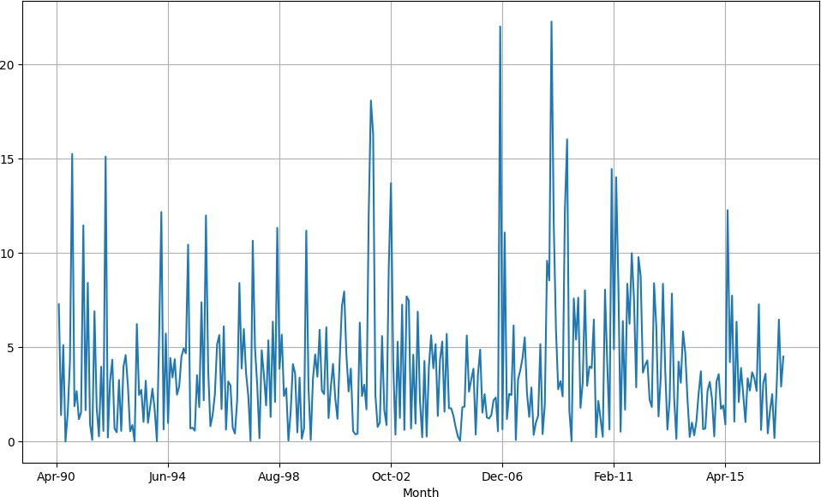

   

#### Figure 2 : **Copra price % Change**

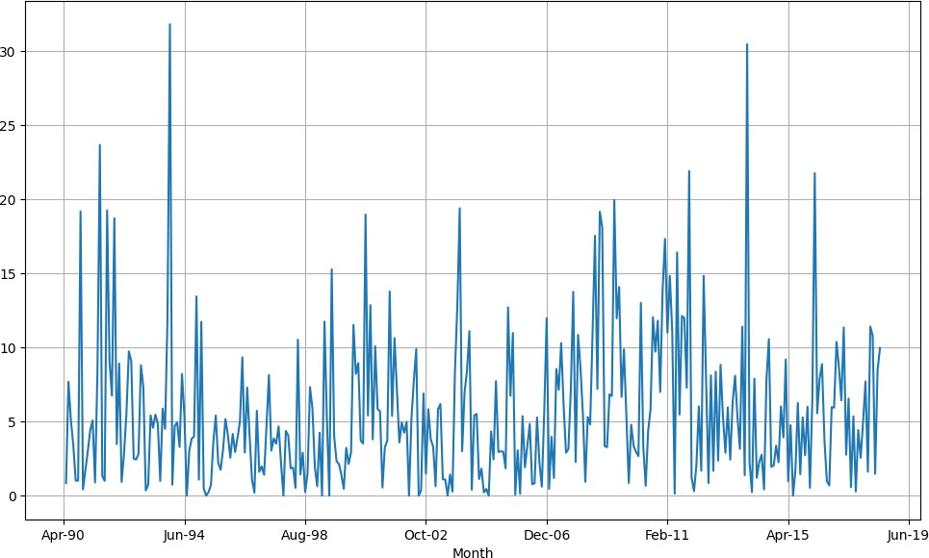

   

#### Figure 3 : **Cotton price % Change**

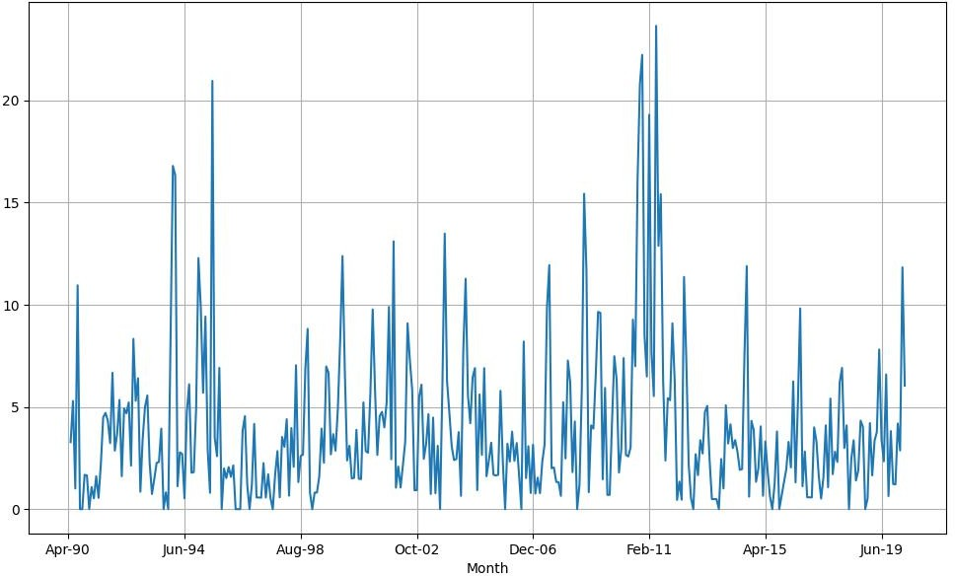

   

#### Figure 4 : **Fine wool price % Change**

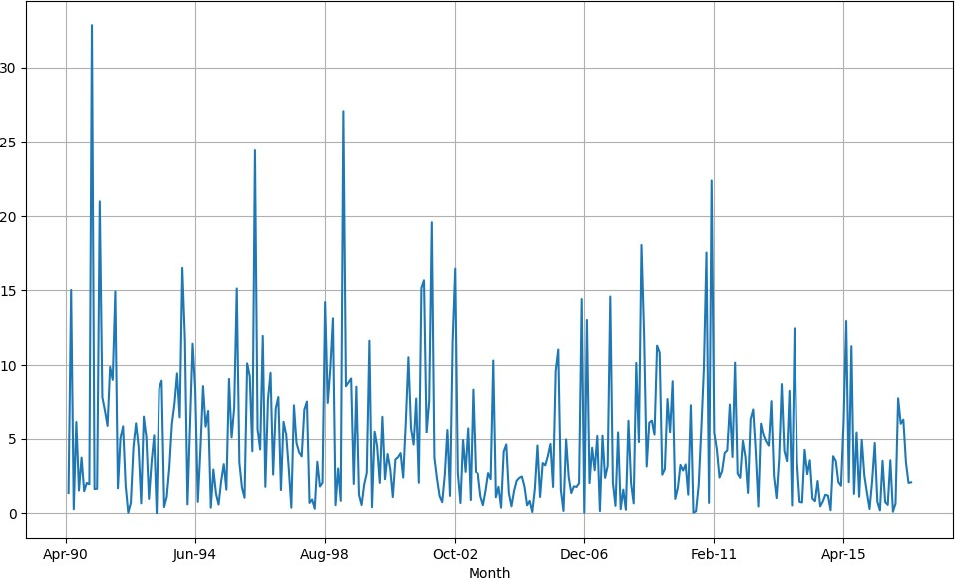

   

#### Figure 5 : **Hard log price % Change**

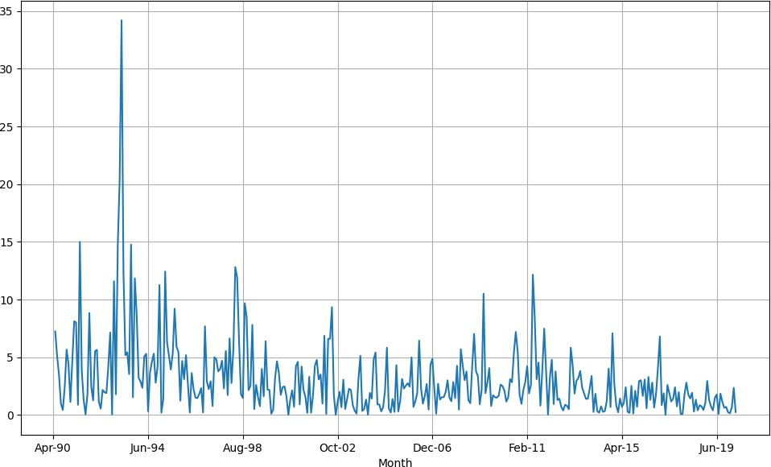

   

#### Figure 6 : **Hide price % change**

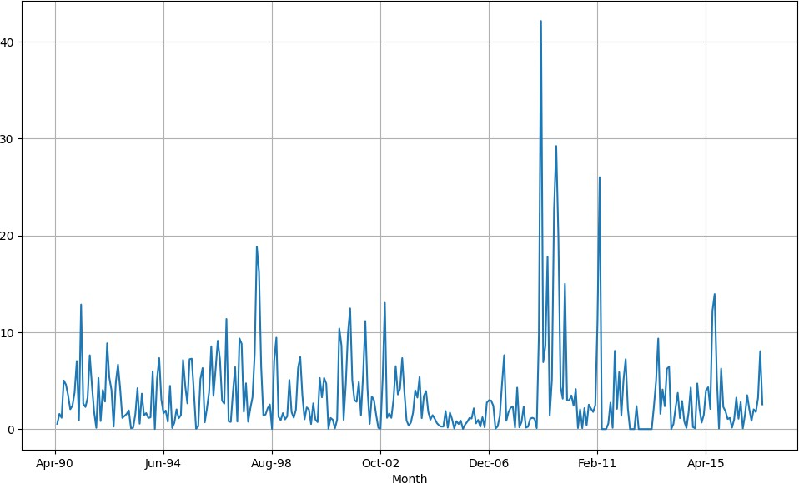

   

#### Figure 7 : **Overall Raw material Price Comparison **

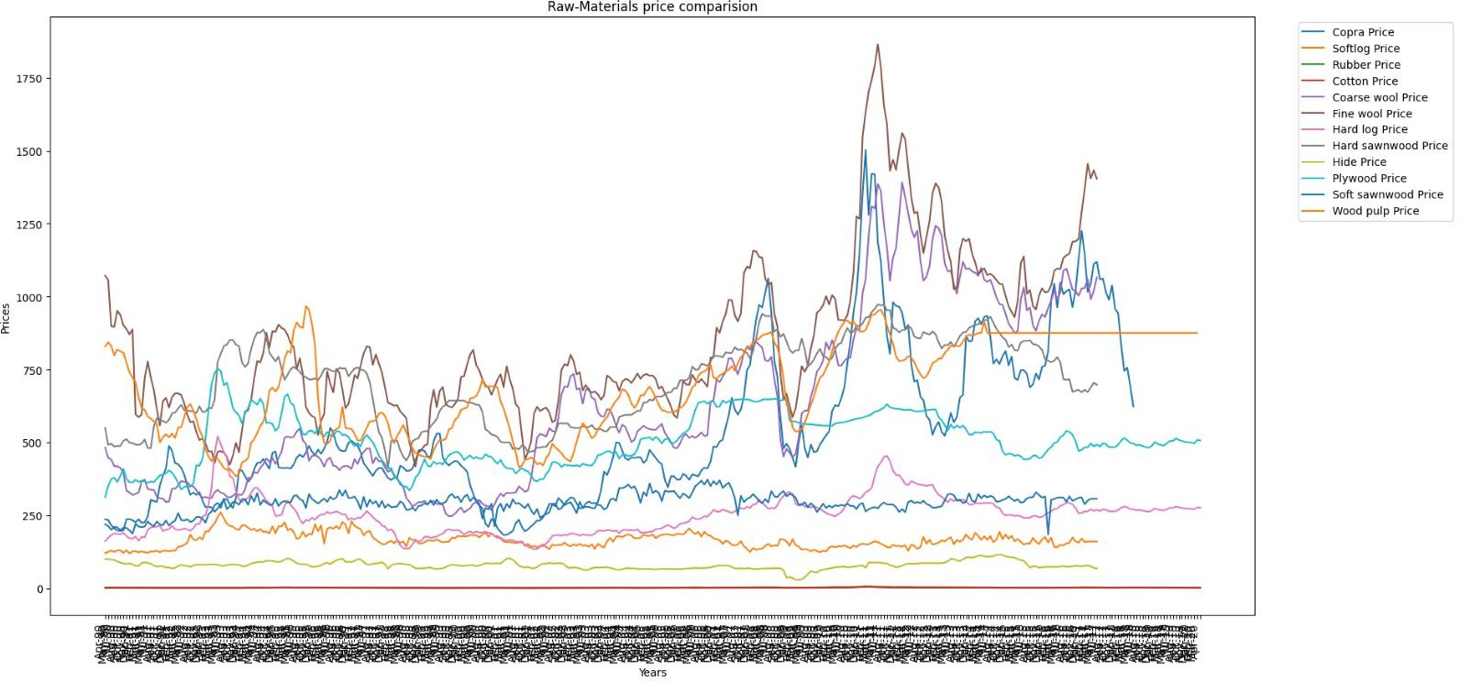

   

## LIST OF TABLES :

#### Table 1 : a)**Coarse wool price(max)**

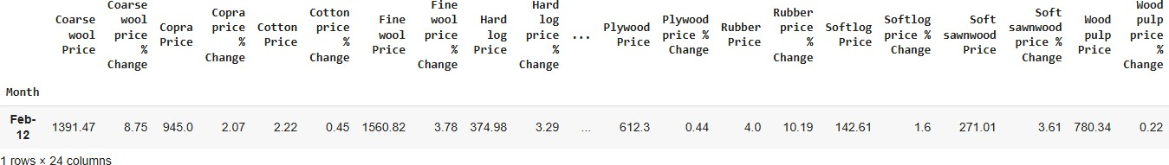

**Table 1: b)**Coarse wool price(min)\*\***

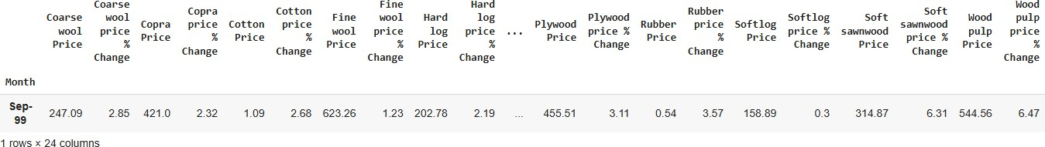

   

#### Table 2 : a)** Cotton Price(max)**

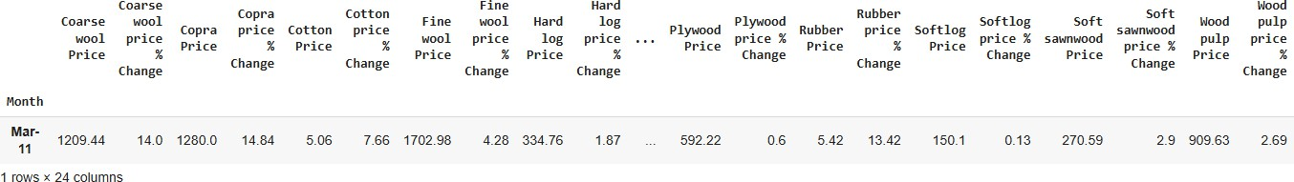

**Table 2 : b)** Cotton Price(min)\*\***

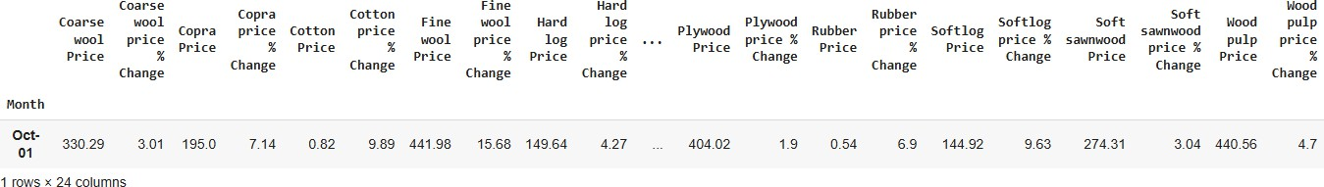

   

#### Table 3 : a) **Fine wool Price(max)**

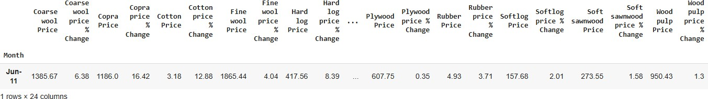

**Table 3 : b) **Fine wool Price(min)\*\***

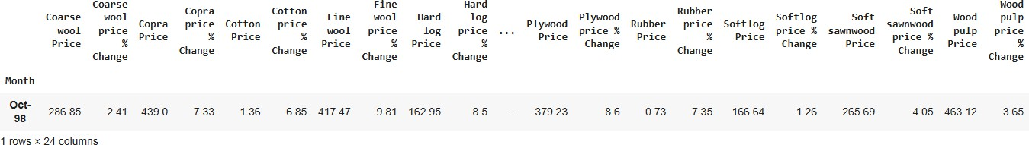

   

#### Table 4 : a)** Hard log Price (max)**

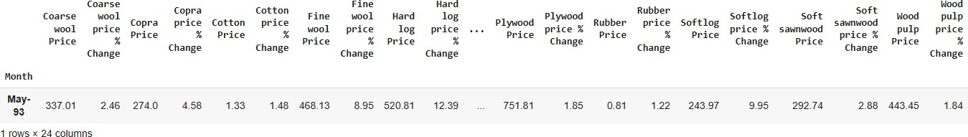

**Table 4 : b)** Hard log Price (min)\*\***

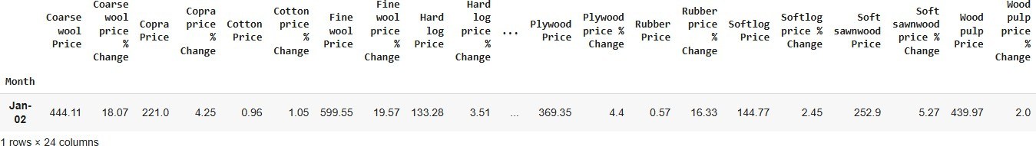

   

#### Table 5 : a) ** Hard sawn wood Price (max)**

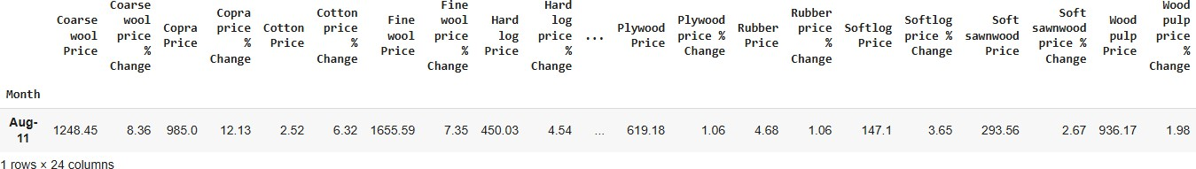

**Table 5 : b)** Hard sawn wood Price (min)\*\***

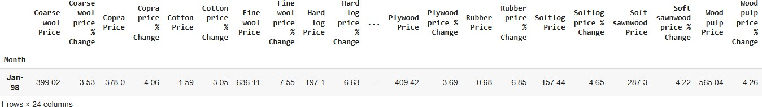

   

#### Table 6 : a) ** Hide Price (max)**

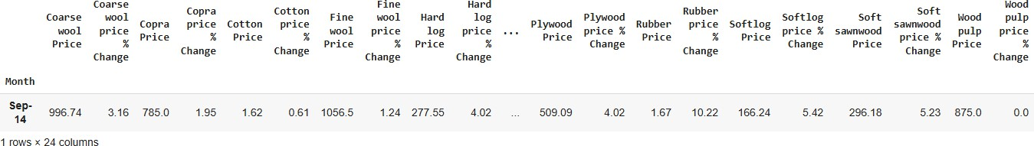

**Table 6 : b) ** Hide Price (min)\*\***

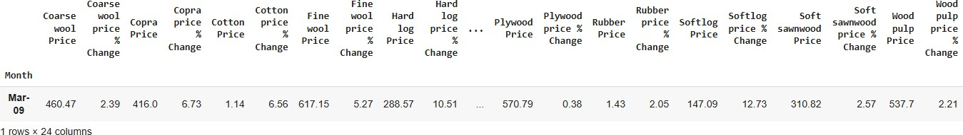

   

#### Table 7 : a)** Plywood Price (max)**



**Table 7 : b)** Plywood Price (min)\*\***

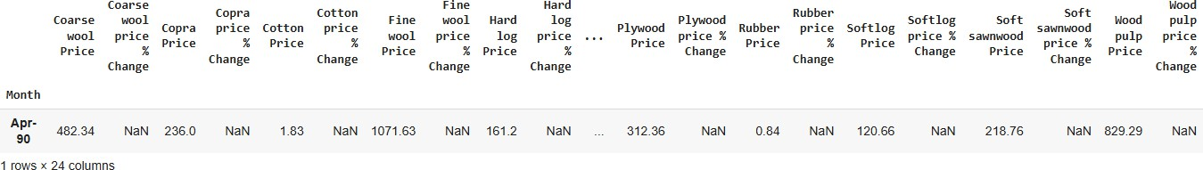

   

#### Table 8 : a)** Rubber Price (max)**

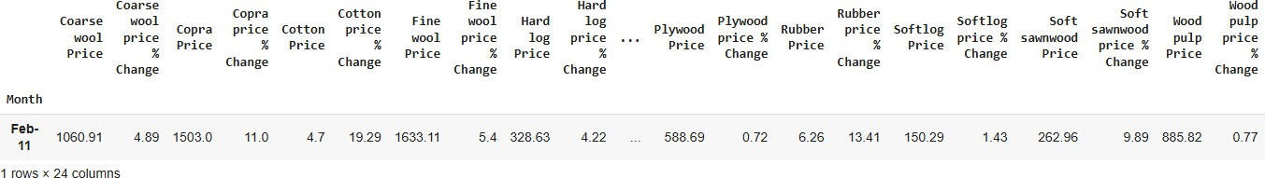

**Table 8 : b)** Rubber Price (min)\*\***

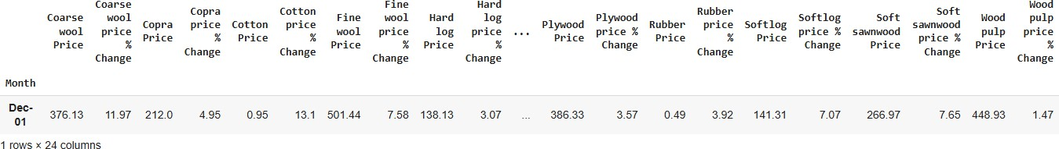

   

#### Table 9 : a)** Softlog Price (max)**

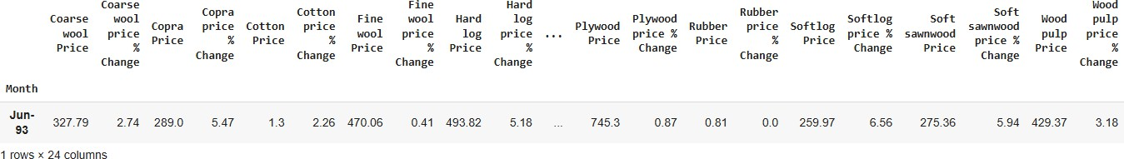

**Table 9 : b)** Softlog Price (min)\*\***

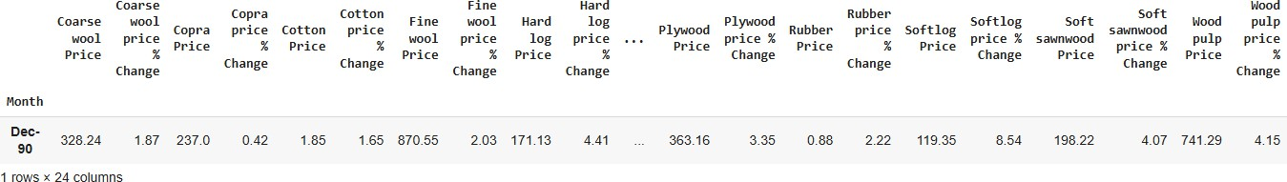

   

#### Table 10 : a)** Soft sawn wood Price (max)**

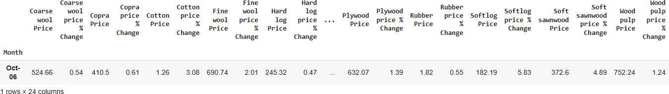

**Table 10 : b)** Soft sawn wood Price (min)\*\***

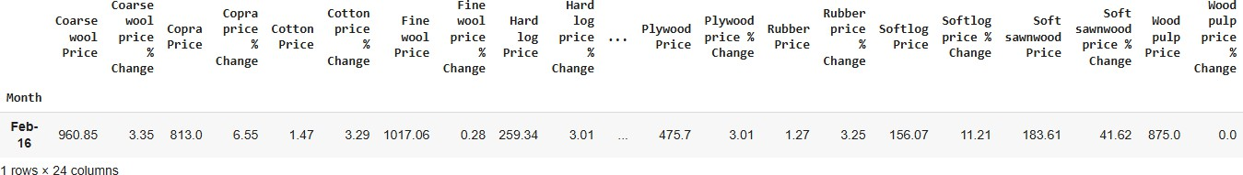

   

#### Table 11 : a)** Wood pulp Price (max)**



**Table 11 : b)** Wood pulp Price (min)\*\***



   

### Problem Statement:

**Introduction CHAPTER 1**

The agricultural sector faces significant challenges in managing the sourcing and quality of raw materials, which are critical for sustainable food production and economic stability. Factors such as climate change, soil degradation, market volatility, and shifting consumer preferences contribute to variability in the availability and quality of agricultural inputs.

There is a pressing need for a comprehensive analysis of agricultural raw materials to understand their current status, assess sustainability practices, and inform decision-making for farmers and stakeholders. This analysis aims to address the following key issues Quality Variability, Supply Chain Disruptions, Sustainability Concerns

### Motivation :

The motivation for this project arises from the need to ensure food security amid a growing global population and increasing demand for high-quality agricultural raw materials. It aims to address sustainability challenges by promoting environmentally friendly practices in sourcing and production. Economic resilience for farmers is critical, as market volatility can impact profitability. Leveraging modern technologies for data analysis will enhance decision-making and resource management. Ultimately, the project seeks to align agricultural practices with consumer demand for transparency and sustainability.

### Objectives:

The primary objective of this analysis is to assess the quality, availability, and sustainability of agricultural raw materials. This includes evaluating factors such as soil health, crop yield, market demand, and environmental impact. The goal is to provide actionable insights that can guide farmers, suppliers, and policymakers in making informed decisions.

* + 1. **Quality Assessment:** Evaluate the quality of key agricultural raw materials, including soil health, crop quality, and nutritional content.
    2. **Availability Analysis:** Analyze the availability of essential raw materials and identify factors that influence their supply.

   

* + 1. **Market Demand Insights:** Understand current market demands and trends for agricultural products to guide production decisions.
    2. **Sustainability Evaluation:** Assess the environmental impact of raw material sourcing and recommend sustainable practices.
    3. **Data Integration:** Develop a framework for integrating various data sources (e.g., agricultural statistics, climate data, market trends) to facilitate ongoing analysis.

### Scope of the Project :

* **Raw Material Types :** Focus on key raw materials such as grains, fruits, vegetables, and livestock feed.
* **Geographical Coverage :** Analyze data from relevant agricultural regions, considering local conditions and practices.
* **Data Collection :** Utilize a combination of field data, satellite imagery, market reports, and climate data.
* **Analytical Methods:** Employ statistical analysis, machine learning models, and geographic information systems (GIS) to derive insights.

### Personalization:

* **Stakeholder Engagement:** Actively involve local farmers, suppliers, and agricultural organizations in the project’s design and execution. Their insights will ensure the analysis addresses real-world challenges and opportunities specific to their needs.
* **Tailored Data Collection:** Customize data collection methods to reflect regional agricultural practices and raw material types. This may include surveys, interviews, and on-site assessments that capture unique local conditions and requirements.
* **Focused Analysis:** Identify and prioritize specific raw materials that are most relevant to the community or region being studied. This focus will enhance the practical applicability of the findings.
* **User-Friendly Reporting:** Develop reports and visualizations that are accessible and understandable to all stakeholders, including those without technical backgrounds. This will facilitate better engagement with the insights generated.

   

* **Feedback Mechanism:** Implement a system for continuous feedback from stakeholders throughout the project. This will allow for ongoing adjustments and ensure that the analysis remains relevant and useful for decision-making.

   

## CHAPTER 2

### Literature Survey

Research highlights the critical role of agricultural raw materials, such as grains and vegetables, in ensuring food security and sustainable practices. Quality assessment studies indicate that factors like soil health and climate significantly impact crop yields (Smith et al., 2021). Availability is further influenced by market dynamics, with climate fluctuations disrupting supply chains (Lee et al., 2022).

Sustainability practices are gaining attention, as they help mitigate environmental degradation while maintaining material viability (Williams & Martin, 2023). Technological advancements, including big data and remote sensing, enhance the accuracy of monitoring agricultural inputs (Chen et al., 2022). Moreover, understanding market trends reveals a growing consumer preference for sustainably sourced products (FAO, 2021).

Lastly, effective policies informed by data can promote sustainable sourcing and bolster resilience in agricultural systems (Anderson, 2022). This literature underscores the need for a comprehensive approach to analyzing agricultural raw materials.

### Existing Models and Techniques :

* + - **Soil Health Assessment Models:** The Soil Quality Index (SQI) evaluates soil health based on indicators like nutrient levels and pH, providing insights into fertility and crop potential. DSSAT (Decision Support System for Agrotechnology Transfer) simulates crop growth under various conditions to aid in yield prediction.
    - **Crop Yield Prediction Techniques:** Machine learning algorithms, such as Random Forest and Support Vector Machines, analyze historical data to forecast future yields based on environmental factors. Remote
    - sensing technologies, including satellite imagery and drones, enable real-time monitoring of crop health and growth.
    - **Supply Chain Analysis Tools:** Input-Output Analysis assesses interdependencies within the agricultural supply chain, helping to identify bottlenecks. Geographic Information Systems (GIS) map crop distribution and optimize logistics for raw material sourcing.
    - **Sustainability Assessment Frameworks:** Life Cycle Assessment (LCA) evaluates the environmental impact of agricultural practices from production to

   

consumption, while sustainability indicators measure factors like water use and carbon footprint.

* + - **Market Analysis Models:** Econometric models forecast market trends by analyzing the relationships between price, demand, and other variables. Consumer preference surveys, using techniques like conjoint analysis, help understand market demand for sustainably sourced products.
    - **Integrated Decision Support Systems:** Agri-Info Systems combine data from various sources, providing stakeholders with comprehensive insights for better decision-making. These tools collectively enhance the efficiency and sustainability of agricultural raw material management.

### Gaps and Limitations in Existing Solutions :

Existing solutions for agriculture raw material analysis exhibit several key limitations. Many rely on incomplete or outdated data, which compromises the accuracy of predictions. There is often difficulty in integrating diverse data sources, resulting in fragmented insights. Additionally, advanced tools can be inaccessible to smallholder farmers due to their complexity. Many analyses focus on short-term yields rather than long-term sustainability, risking soil health and biodiversity. Limited real-time monitoring capabilities hinder timely responses to changing conditions. Furthermore, market analyses may not fully capture shifting consumer preferences for sustainability. Socioeconomic factors influencing agricultural practices are frequently overlooked, and current sustainability frameworks often inadequately assess cumulative environmental impacts.

* 1. **Project Approach to Address Gaps :**

To address the gaps in agriculture raw material analysis, the project will implement a comprehensive data collection strategy that includes both historical and real-time data from various sources. An integrated platform will combine diverse data types—such as soil health, climate, and market trends—into a cohesive framework, providing holistic insights for stakeholders. User-friendly tools will be developed to ensure accessibility for non-technical users, enabling smallholder farmers to easily interpret and act on the information.

   

Additionally, a focus on long-term sustainability and real-time monitoring will enhance decision-making and promote regenerative agricultural practices.

   

## CHAPTER 3

### Proposed Methodology

### Define Objectives and Scope

* + - Clearly outline the project goals, including specific questions to be addressed regarding raw material quality, availability, and sustainability. Define the geographical and agricultural contexts for the analysis.

### Data Collection

* + - **Identify Sources:** Gather data from a variety of sources, including IoT sensors for real-time monitoring, satellite imagery for crop health assessment, and local weather stations for climatic data.
    - **Conduct Surveys:** Engage with farmers and stakeholders to collect qualitative data on practices, challenges, and market perceptions.

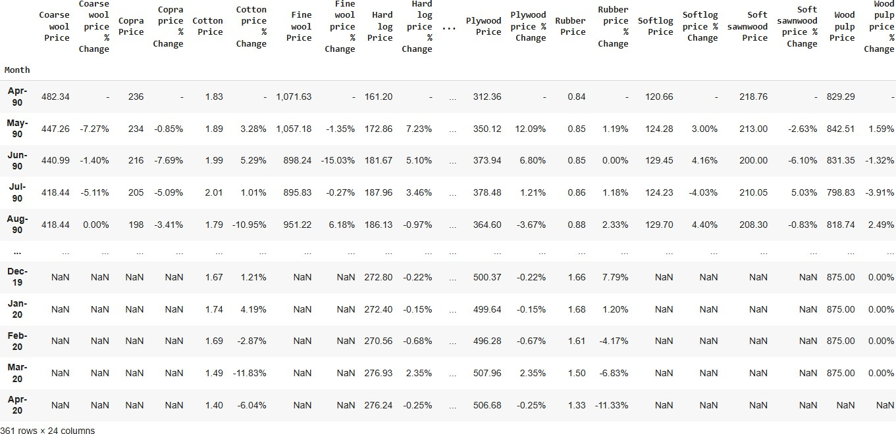

   

### Data Integration and Management

* + - **ETL Processes:** Implement Extract, Transform, Load (ETL) processes to clean and integrate data into a centralized database, ensuring consistency and reliability.
    - **Data Warehouse Creation:** Set up a data warehouse to facilitate efficient storage and retrieval of integrated data.

### Analysis and Modeling

* + - **Statistical Analysis:** Conduct descriptive and inferential statistical analyses to understand trends and correlations in the data.
    - **Predictive Modeling:** Utilize machine learning algorithms to develop predictive models for crop yields and market demands, training models on historical data.

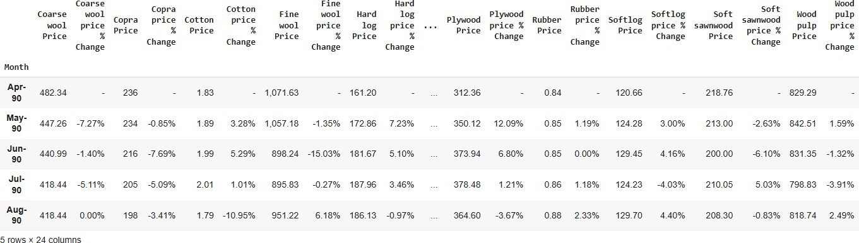

* + - **Simulation Modeling:** Use tools like DSSAT to simulate various agricultural scenarios and assess their impacts on raw material outputs.

   

### User Interface Development

* + - **Dashboard Creation:** Design an interactive dashboard that presents key metrics, data visualizations, and analytical insights in a user-friendly format.
    - **Mobile Access:** Ensure that the interface is accessible via mobile devices to facilitate use in the field.

### Validation and Testing

* + - **Model Validation:** Test the accuracy of predictive models against real-world data to refine algorithms and improve reliability.
    - **User Testing:** Conduct usability testing with target users to gather feedback on the interface and functionalities, making necessary adjustments.

### Implementation and Training

* + - **Deployment:** Roll out the system in a phased manner, starting with pilot regions to monitor performance and user engagement.
    - **Training Sessions:** Provide training for users on how to utilize the system effectively, ensuring they understand its features and benefits.

### Monitoring and Evaluation

* + - **Continuous Feedback Loop:** Establish mechanisms for ongoing user feedback and system performance monitoring to identify areas for improvement.

   

* + - **Impact Assessment:** Periodically assess the impact of the system on agricultural practices and productivity, adjusting methodologies as needed based on findings.

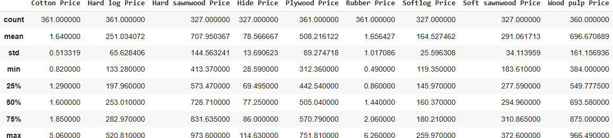

   

# Chapter 4

### Implementation and Results

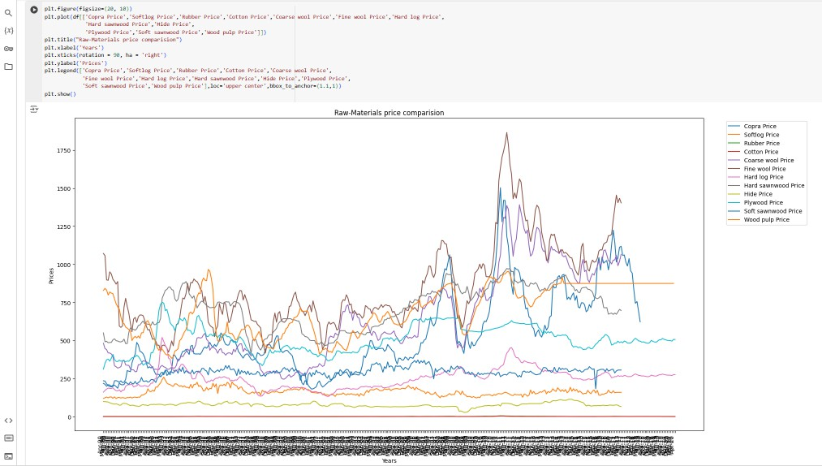

### Result

In the Results section of a sentiment analysis project, you would include

### High and Low Price Raw Materials :

* + **High Average Price Raw Materials**:
    - Identify specific materials (e.g., organic grains, specialty crops) with the highest average prices over the analyzed period.
    - **Low Average Price Raw Materials:**
      * Identify materials (e.g., certain grains or feedstocks) with the lowest average prices.

### High and Low Percentage Change Materials

* + **High Percentage Change:**

   

* + - List raw materials that experienced significant price increases (e.g., +30% year-over-year), possibly due to demand spikes or supply chain disruptions.
  + **Low Percentage Change:**
    - Identify materials with minimal price fluctuation, indicating stable markets (e.g., basic staples with steady demand).

### Price Range Changes Over the Years

* + **Trends:**
    - Highlight trends in price movements over time, such as:
* Materials that have seen consistent price increases (e.g., due to increasing production costs).
* Materials with volatility in prices due to seasonality or market events.
  + **Visualizations:**
    - Box plots or line graphs showing how the price distribution has evolved, revealing seasonal patterns or significant events.

### Correlation Analysis

* + **Heatmap Insights:**
    - Present a heatmap that shows the correlation coefficients between different raw materials' price changes.
    - Discuss correlations found (e.g., positive correlations between certain grains indicating that their prices tend to move together).
    - Identify any surprising correlations, such as negative relationships that may indicate competition or market dynamics.

   

### Key Findings :

# CHAPTER 5

**Discussion and Conclusion**

* + 1. Certain organic and specialty crops have the highest average prices, reflecting increasing consumer demand for premium products.
    2. Basic staples like conventional grains show lower average prices, indicating a stable and abundant supply.
    3. Significant price volatility was observed in materials like oilseeds, driven by market disruptions and climatic factors.
    4. Strong positive correlations exist among similar raw materials, while negative correlations were noted between competing crops.
    5. Historical trends suggest that external influences such as weather and trade policies significantly impact pricing dynamics.

### Git Hup Link Of The Project

<https://github.com/vikramvishu05/vikram.git>

**5.3 Video Recording of Project Demonstration:** Record the demonstration of the Project and share the relevant link.



<https://youtu.be/tMcw1IxlUpM?si=ycmuLsZwMidn4jVi>

   

### Limitations :

* + 1. The dataset may contain missing entries, affecting the overall accuracy of the analysis.
    2. The analysis focused on a limited selection of raw materials, possibly overlooking significant trends in other areas.
    3. Price fluctuations can be influenced by short-term events that may not be fully captured in the dataset.
    4. Broader economic and environmental factors might not be adequately considered, limiting the insights on price dynamics.
    5. The methods used may oversimplify relationships, not accounting for non-linear effects or external variables.

# Future Work:

* + 1. Expand the dataset to include more raw materials and geographic regions for a broader analysis of price trends.
    2. Utilize advanced machine learning techniques to enhance predictive modeling of price changes and identify complex patterns.
    3. Investigate the impact of specific external factors, such as climate change and policy shifts, on agricultural prices over time.
    4. Conduct longitudinal studies to capture long-term trends and cyclical patterns in pricing.
    5. Gather qualitative insights from stakeholders through surveys to better understand market dynamics and inform decision-making.

# Summaries Inferences & Conclusion

##### Suppose we are planning some business which required my own raw material than this information will help,

* + The given information includes the prices of various raw materials such as Coarse wool, Copra, Cotton, Fine wool, Hard log, Hard sawn wood, Hide, Plywood, Rubber, Soft log, Soft sawn wood, and Wood pulp.
  + The respective prices of these raw materials are 320, 471, 1.29, 469, 275, 880,

76, 650, 0.89, 158, 230, and 880 (rounded figures).

* + Analyzing the trends in the prices of these raw materials can help us understand which crops are profitable to grow in the future.
  + Based on this information, we can forecast the future prices of these raw materials and make a budget accordingly.

##### Costing according to time period

   

* + For instance, if a business requires a particular raw material during a specific month, analyzing the historical trends in the prices of that material can help in forecasting its future prices. Based on the forecasted prices and the budget allocated for that particular period, the business can plan for the procurement of the raw material.

##### Overlapping Observation

* + Overlapping of raw materials in the price chart does not necessarily mean that the requirement for all materials is the same throughout the year. Each raw material has its unique demand and supply factors that affect its price, and the demand for different materials can vary depending on various factors such as seasonal changes, industry trends, and market conditions.
  + For example, the demand for cotton may be higher during the summer months when clothing production increases, while the demand for rubber may be higher during the rainy season when there is an increased need for tires and other rubber products. Similarly, the demand for wood products may be higher during the construction season, while the demand for animal hides may be higher during the winter months when the demand for leather products increases.
  + Therefore, it is important to analyze the demand and supply factors for each raw material separately to understand its unique requirements and forecast its future prices accordingly. This information can help businesses make informed decisions about their procurement and production strategies and ensure that they have sufficient raw materials to meet their production needs.

   

## REFERENCES :

1. Worldometer : largest countries in the world by area 2023;2023. [https://www.worldometers.info/geography/largest-countries-in-the-world/.](https://www.worldometers.info/geography/largest-countries-in-the-world/)
2. Jung J, Maeda M, Chang A, Bhandari M, Ashapure A, Landivar-Bowles J. The potential of remote sensing and artificial intelligence as tools to improve the resilience of agriculture production systems. Curr Opin Biotechnol. 2021;70:15–22.

THANKING YOU. !!!